Lab 2：MATLAB Programming

Authors | Name：何衍宁 Student ID:12311512  Name：夏天 Student ID:12311610
Objective
2.10
In Lab 2, we used MATLAB to enhance our grasp of basic signal processing techniques, focusing on convolution of discrete signals, solving difference equations with filter functions, and exploring autocorrelation functions to analyze signal properties Skills, also gave us a deeper understanding of linear systems and practical applications such as echo estimation, which is crucial for areas such as communications and audio processing.

Lab results & Analysis
2.10
The signal y[n], represented by the vector y, is of the form
y[n] = z[n] + ax[n - N] (2.21)
where x[n] is the uncorrupted speech signal, which has been delayed by N samples and added back in with its amplitude decreased by a < 1. This is a reasonable model for an echo resulting from the signal reflecting off of an absorbing surface like a wall. If a microphone is placed in the center of a room, and a person is speaking at one end of the room, the recording will contain the speech which travels directly to the microphone, as well as an echo which traveled across the room, reflected off of the far wall, and then into the microphone. Since the echo must travel further, it will be delayed in time. Also, since the speech is partially absorbed by the wall, it will be decreased in amplitude. For simplicity ignore any further reflections or other sources of echo. For the problems in this exercise, you will use the value of the echo time, N = 1000, and the echo amplitude, a = 0.5.

2.10a(impulse response)

Basic Problems
(a). In this exercise you will remove the echo by linear filtering. Since the echo can be represented by a linear system of the form Eq. (2.21), determine and plot the impulse response of the echo system Eq. (2.21). Store this impulse response in the vector he for 0 < n < 1000.
The problem requires the unit impulse response of the audio system to be made and plotted.
Analysis:
In this problem, the echo system y[n] = x[n] + αx[n-N], as a LTI system, has a impulse response. The impulse response must be x[n] = δ[n]. We need to store the impulse response in a vector “he” for 0 < n < 1000. That means we need to make impulse response in n = 1,2,3…,999. Finally, we plot it.
clc;
clear;
N=1000;
load lineup.mat
n=1001:2001;
m=0:1000;
label=0:1000;
x=[zeros(1,1000),1,zeros(1,1000)];
he(n)=x(n)+0.5*x(n-N);
stem(m,he(n));
grid on;
xlabel('n');
ylabel('he[n]');
legend('he[n]');

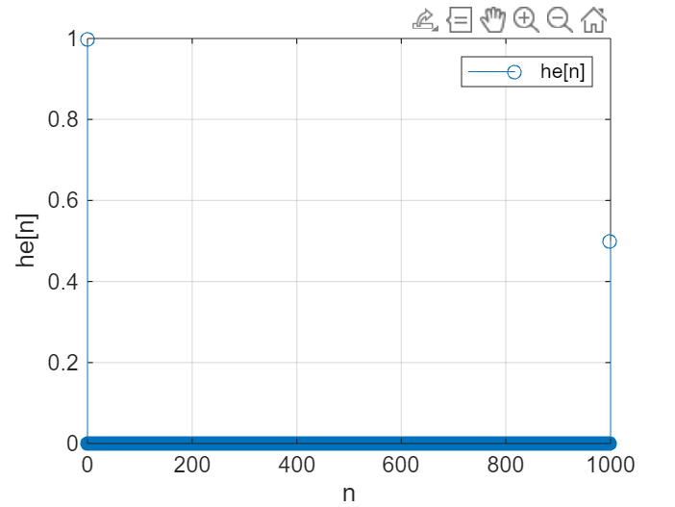

Lab result:
Because of the echo system, we could know when it comes to n = 0, the response must be 1; when it comes to n=1000, the response must be α. And in this problem, we determine that αis 0.5. So when it comes to n=1000, he[1000]=0.5. Since we know he[0]=1,he[1000]=0.5, from the figure, the code we made is correct.

2.10b (removal system)
It is required to prove that the system shown by Eq. (2.22) is the inverse of the system shown by Eq. (2.21). And the statement z[n]=x[n] is valid solution.
(b). Consider an echo removal system described by the difference equation where y[n] is the input and z[n] is the output which has the echo removed.
z[n] + az[n-N] = y[n] (2.22)
Show that Eq. (2.22) is indeed an inverse of Eq. (2.21) by deriving the overall difference equation relating z[n] to x[n]. Is z[n] = x[n] a valid solution to the overall difference equation?
Analysis:
In this problem, z[n] + az[n-N] = y[n] should be proved as the inverse system. We need to take the 2.21 to 2.22, so that z[n] +az[n-N] = x[n] + ax[n-N]. To deriving the overall difference equation relating z[n] to x[n], z[n] + az[n-N] =x[n] + ax[n-N]. Reducing the equation, from x[n] = z[n]. the right side of equation equals to the left side. So the z[n] = x[n] is valid solution.
clc;
clear;
N=1000;
load lineup.mat
x=randn(1,7000);
%in order to get the equation
A = [1, zeros(1,999),0.5];
%for overall difference equation
z = filter(A,A,x);
difference = norm(x-z);
if difference < 1e-6
fprintf('z[n] effectively reproduces x[n], showing that the echo removal system works.\n');
else
fprintf('There is a significant difference between x[n] and z[n].\n');
end
subplot(211);
stem(x);
title('Original Signal x[n]');
subplot(212);
stem(z);
title('Output Signal z[n]');
z[n] effectively reproduces x[n], showing that the echo removal system works.
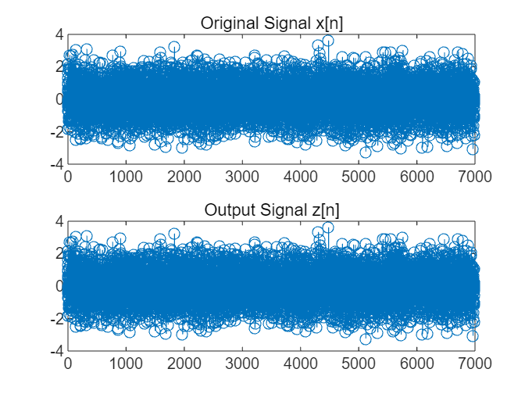

Lab result:
The unit impulse responses of the two systems are given by:
y[n] =x[n] + ax[n - N]
z[n] + az[n - N] =y[n]
Thus, the two unit impulse functions are inverses of each other, proving that the system shown in Eq. (2.22) is the inverse system of the one shown in Eq. (2.21).
From the figure, we could find that z[n] = x[n], that prove the result we just come to is right.

2.10c (response)
The problem requires to find the first 4001 bits of the infinite impulse response of the system shown in Eq. (2.22) and draw a diagram.
Intermediate Problems
(c). The echo removal system Eq. (2.22) will have an infinite-length impulse response. Assuming that N = 1000, and a = 0.5, compute the impulse response using filter with an input that is an impulse given by d= [I zeros (I, 4000) 1. Store this 4001 sample approximation to the impulse response in the vector her.
Analysis:
The input signal is d, and the image can be drawn as required. For the problem, we should build difference equation to calculate d in system. As we use N=1000, alpha=0.5, what we do is to find out A and B in difference equation.
clc;
clear;
N=1000;
a=0.5;
load lineup.mat
%for the equation 2.22, input is y[n]
d = [1 zeros(1,4000)];
%d as input
A = [1,zeros(1,999),a];
B = 1;
her = filter(B,A,d);
figure;
stem(her);
grid on;
xlabel('n');
ylabel('her[n]');
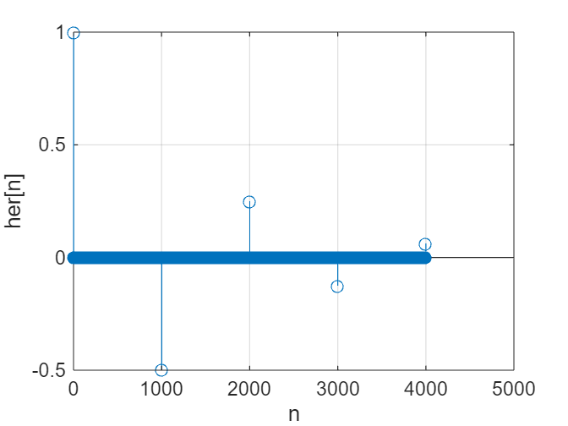

Lab result:
The first 4001 bits of the infinite impulse response of the system shown in Eq. (2.22) are shown in the figure. From the equation (2.22) we have, z[0]=1,z[1000]=-0.5,z[2000]=0.25,z[3000]=-0.125,z[4000]=0.0625
The figure result is correct with the equation(2.22), so the code is correct.

2.10d (echo)
(d). Implement the echo removal system using z=filter (1, a, y), where a is the appro- priate coefficient vector derived from Eq. (2.22). Plot the output using plot. Also, listen to the output using sound. You should no longer hear the echo.
The problem requires the implementation of echo cancellation system and mapping and testing of noise cancellation quality.
Analysis:
Just follow the instructions of the question. We should the y in lineup.mat, and do z=filter(1,a,y) to plot the output.
clc;
clear;
N=1000;
alpha=0.5;
load lineup.mat
a=[1,zeros(1,999),0.5];
z=filter(1,a,y);
plot(z);
grid on;
xlim([0,7000]);
xlabel('n');
ylabel('z[n]');
%sound without echo
sound(z);
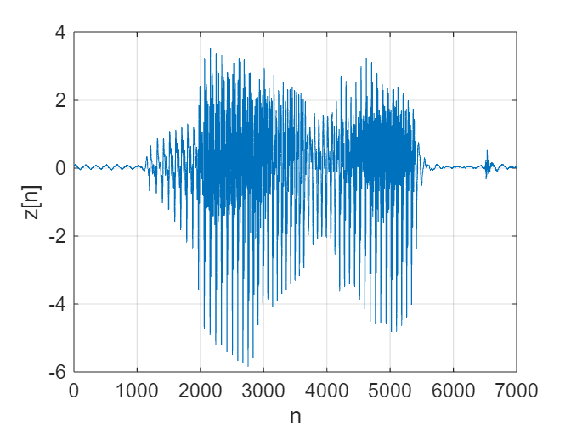

Lab result:
The diagram is shown in the figure. After the filtering operation of the echo cancellation system, the noise is obviously eliminated. We use the filter to complete the system. And finally, we could hear the sound “lineup” clearly.

2.10e (conv)
The problem asks to make the convolution of he and her, observe whether it is the unit impulse function, plot and interpret the result.
(e). Calculate the overall impulse response of the cascaded echo system, Eq. (2.21), and echo removal system, Eq. (2.22), by convolving he with her and store the result in hoa. Plot the overall impulse response. You should notice that the result is not a unit impulse. Given that you have computed her to be the inverse of he, why is this the case?
Analysis:
Make images according to the requirements of the topic. We just calculate the convolution of he and her to be hoa. Then plot hoa to find if it is a unit impulse function.
clc;
clear;
N=1000;
alpha=0.5;
load lineup.mat
x=[1,zeros(1,1000)];
A=[1,zeros(1,999),0.5];
B=1;
d=[1,zeros(1,4000)];
he=filter(A,B,x);
her=filter(B,A,d);
hoa=conv(he,her);
figure;
stem(hoa);
grid on;
xlabel('n');
ylabel('hoa[n]');
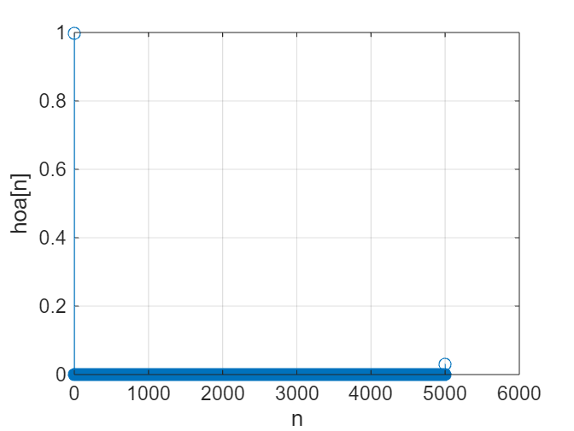

Lab result:
hoa[5000] is not equal to 0, so hoa is not a unit impulse function. According to the analysis in b, he and her should respond inversely to each other.
The reason why hoa[5000] does not equal 0 here is that her was originally an infinitely long response, but was truncated in subsequent operations, resulting in a volume of the last bit.
The product result was changed.

2.10f(response)

The question requires that Rxx[n] is used to represent the autocorrelation action signal Ryy[n] of y[n] and make a graph, and Ryy[n] is used to calculate the system y_n. Since we change the lineup.mat to lineup_n.mat. So we need not to calculate y2 and y3. We just need to calculate N and alpha of y_n.
Advanced Problem (f). Suppose that you were given y[n] but did not know the value of the echo time, N, or the amplitude of the echo, a. Based on Eq. (2.21), can you determine a method of estimating these values? Hint: Consider the output y of the echo system to be of the form: y [n] = x[n] * (6[n] + a6[n - N]) and consider the signal, This is called the autocorrelation of the signal y[n] and is often used in applications of echo-time estimation. Write Ryy [n] in terms of R,,[n] and also plot R,,[n]. You will have to truncate y[n] before your calculations to keep R,,[n] within the limitations of the Student Edition of MATLAB. You will find that many of the properties of the autocorrelation will still hold when y is truncated. Also try experimenting with simple echo problems such as
>>NX=100;
>>x=randn(1,NX);
>>N=50;
>>alpha=0.9;
>>y=filter([1 zeros(1,N) alpha,1,x];
>>Ryy=conv(y,filplr(y));
>>plot([-NX+1:NX-1].Ryy)
by varying N,alpha, and NX. Also, when you loaded lineup.mat, you loaded in two additional vectors. The vector y2 contains the phrase "line up" with a different echo time N and different echo amplitude a. The vector y3 contains the same phrase with two echoes, each with different times and amplitudes. Can you estimate N and alpha for y2, and NI, alpha, N2, and a2 for y3?
Analysis:
For the lineup_n.mat, we have y_n in column. So we could not use fliplr, which is for row. Instead, we use flipud to make y_n[n] to y_n[-n].
𝑅𝑦𝑦[𝑛] = 𝑦[𝑛] ∗ y[-𝑛] = 𝑥[𝑛] ∗ 𝑥[-𝑛] ∗ (𝛿[𝑛] + 𝛼 𝛿[𝑛 - 𝑁]) ∗ (𝛿[- 𝑛] + 𝛼 𝛿[- 𝑛 - 𝑁])
because 𝛿 [𝑛] is even functions.
The original type
Ryy[n]=𝑅𝑥𝑥[𝑛] ∗ (𝛿 [𝑛] + 𝛼 𝛿 [𝑛 - 𝑁] + 𝛼 𝛿 [𝑛 + 𝑁] + (𝛼 ^ 2) * 𝛿 [𝑛])
= (𝛼 ^ 2 + 1) 𝑅𝑥𝑥[𝑛] + 𝛼 𝑅𝑥𝑥[𝑛 - 𝑁] + 𝛼𝑅𝑥𝑥[𝑛 + 𝑁]
Then, we could use the equation that Ryy related to Rxx, to find Rxx from Ryy, since Rxx=x[n]*x[-n].
clc;
clear;
load lineup_n.mat;
n=-6999:6999;
%since we find y_n is ordered in column, we use flipud instead of fliplr
Ryy=conv(y_n,flipud(y_n));
figure;
plot(n,Ryy);
grid on;
xlabel('n');
ylabel('Ryy');
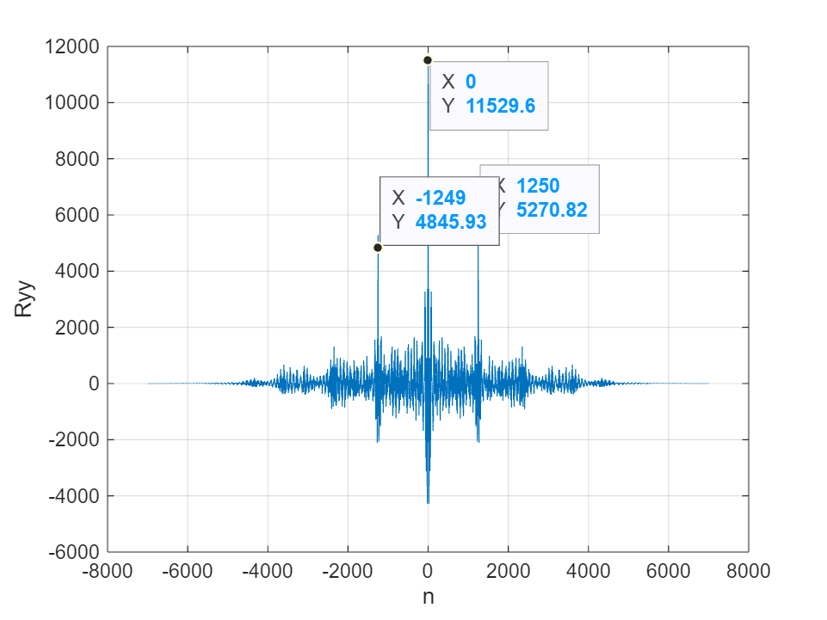

Lab result:
From the above analysis, we can see that Ryy is an axisymmetric signal. Since the peak value of the continuous real autocorrelation function is obtained at the origin, the origin is
The value = (𝛼^2+1) *Rxx (0) +2𝛼Rxx[N]. By the property of continuous real autocorrelation function, the estimation can be ignored 2𝛼Rxx[N].
Similarly, the corresponding points for the two sub-peaks are 𝛼𝑅𝑥𝑥[𝑛-𝑁] and 𝛼𝑅𝑥𝑥[𝑛+𝑁]. Therefore, the distance between the highest peak and the sub-peak is N. As can be seen from the picture
y_n corresponds to N of 1250, N=1250.
It is estimated that the highest peak value is (𝛼^2+1)𝑅𝑥𝑥[0], and the second highest peak value is 𝛼𝑅𝑥𝑥[0]. Thus there is
(𝛼 ^ 2 + 1) 𝑅𝑥𝑥 [0] / 𝛼 𝑅𝑥𝑥 [0] = 11529.6/5270.82,
Since αunder 1, 𝛼 = 0.494.
Conclusion: The calculation results are shown above. The parameters 𝛼 and N of unknown signals can be estimated by using this autocorrelation method. As we get, y_n has N=1250 and 𝛼 = 0.494.

Note: Please indicate meaning of the symbols in all expressions. Please indicate the coordinate and unit in all figures.
Experience
- We have struggled to grasp how signals combine through convolution, particularly in discrete systems, and how to interpret the resulting output signal. We understand this through discussions among our teammates.
- Calculating and interpreting autocorrelation functions to analyze signal properties can be complex. Understanding the significance of peaks and their locations in autocorrelation plots, which indicate the presence of periodicity or similarity within a signal, might have posed a challenge. We understand these things with extra practice.
- We have encountered syntax errors, logical errors in implementing the algorithms, or unexpected results that required thorough debugging and problem-solving skills. We correct through line-by-line analysis.
Score | 100/100

字体：英文Times new Roman；

